**Report on TCP/IP**

**What is TCP/IP?**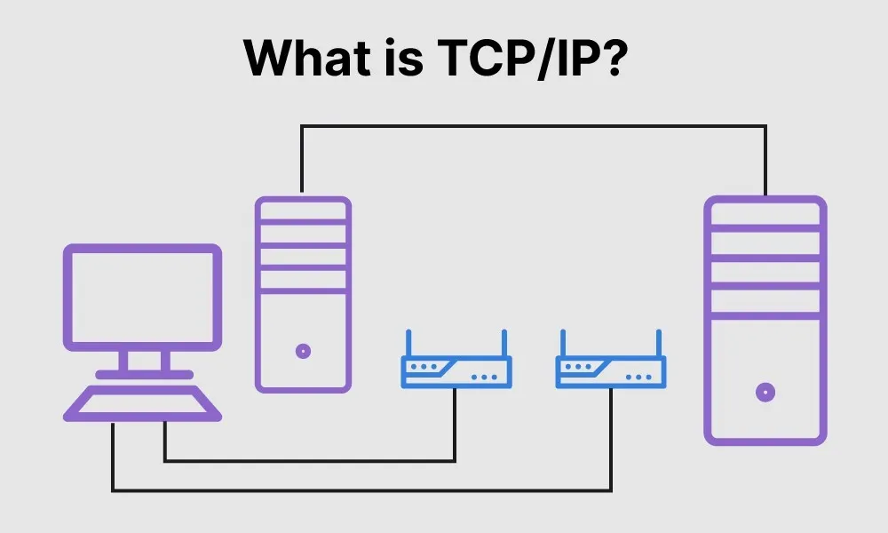

TCP/IP stands for Transmission Control Protocol/Internet Protocol and is a suite of communication protocols used to interconnect network devices on the internet. TCP/IP is also used as a communications protocol in a private computer network (an intranet or extranet).

The entire IP suite -- a set of rules and procedures -- is commonly referred to as TCP/IP. TCP and IP are the two main protocols, though others are included in the suite. The TCP/IP protocol suite functions as an abstraction layer between internet applications and the routing and switching fabric.

TCP/IP specifies how data is exchanged over the internet by providing end-to-end communications that identify how it should be broken into packets, addressed, transmitted, routed and received at the destination. TCP/IP requires little central management and is designed to make networks reliable with the ability to recover automatically from the failure of any device on the network.

The two main protocols in the IP suite serve specific functions. TCP defines how applications can create channels of communication across a network. It also manages how a message is assembled into smaller packets before they are then transmitted over the internet and reassembled in the right order at the destination address.

IP defines how to address and route each packet to make sure it reaches the right destination. Each gateway computer on the network checks this IP address to determine where to forward the message.

A subnet mask tells a computer, or other network device, what portion of the IP address is used to represent the network and what part is used to represent hosts, or other computers, on the network.

Network address translation (NAT) is the virtualization of IP addresses. NAT helps improve security and decrease the number of IP addresses an organization needs.

**Common TCP/IP protocols include the following:**

* Hypertext Transfer Protocol (HTTP) handles the communication between a web server and a web browser.
* HTTP Secure handles secure communication between a web server and a web browser.
* File Transfer Protocol handles transmission of files between computers.

**How does TCP/IP work?**

TCP/IP uses the client-server model of communication in which a user or machine (a client) is provided a service, like sending a webpage, by another computer (a server) in the network.

Collectively, the TCP/IP suite of protocols is classified as stateless, which means each client request is considered new because it is unrelated to previous requests. Being stateless frees up network paths so they can be used continuously.

The transport layer itself, however, is stateful. It transmits a single message, and its connection remains in place until all the packets in a message have been received and reassembled at the destination.

The TCP/IP model differs slightly from the seven-layer Open Systems Interconnection (OSI) networking model designed after it. The OSI reference model defines how applications can communicate over a network.

**Why is TCP/IP important?**

TCP/IP is nonproprietary and, as a result, is not controlled by any single company. Therefore, the IP suite can be modified easily. It is compatible with all operating systems (OSes), so it can communicate with any other system. The IP suite is also compatible with all types of computer hardware and networks.

TCP/IP is highly scalable and, as a routable protocol, can determine the most efficient path through the network. It is widely used in current internet architecture.

**The 4 layers of the TCP/IP model**

TCP/IP functionality is divided into four layers, each of which includes specific protocols:

**The application layer** provides applications with standardized data exchange. Its protocols include HTTP, FTP, Post Office Protocol 3, Simple Mail Transfer Protocol and Simple Network Management Protocol. At the application layer, the payload is the actual application data.

**The transport layer** is responsible for maintaining end-to-end communications across the network. TCP handles communications between hosts and provides flow control, multiplexing and reliability. The transport protocols include TCP and User Datagram Protocol, which is sometimes used instead of TCP for special purposes.

**The network layer**, also called the internet layer, deals with packets and connects independent networks to transport the packets across network boundaries. The network layer protocols are IP and Internet Control Message Protocol, which is used for error reporting.

**The physical layer**, also known as the network interface layer or data link layer, consists of protocols that operate only on a link -- the network component that interconnects nodes or hosts in the network. The protocols in this lowest layer include Ethernet for local area networks and Address Resolution Protocol.

**Uses of TCP/IP**

TCP/IP can be used to provide remote login over the network for interactive file transfer to deliver email, to deliver webpages over the network and to remotely access a server host's file system. Most broadly, it is used to represent how information changes form as it travels over a network from the concrete physical layer to the abstract application layer. It details the basic protocols, or methods of communication, at each layer as information passes through.

**Pros and cons of TCP/IP**

The advantages of using the TCP/IP model include the following:

* helps establish a connection between different types of computers;
* works independently of the OS;
* supports many routing protocols;
* uses client-server architecture that is highly scalable;
* can be operated independently;
* supports several routing protocols; and
* is lightweight and doesn't place unnecessary strain on a network or computer.

The disadvantages of TCP/IP include the following:

* is complicated to set up and manage;
* transport layer does not guarantee delivery of packets;
* is not easy to replace protocols in TCP/IP;
* does not clearly separate the concepts of services, interfaces and protocols, so it is not suitable for describing new technologies in new networks; and
* is especially vulnerable to a synchronization attack, which is a type of denial-of-service attack in which a bad actor uses TCP/IP.

**How are TCP/IP and IP different?**

There are numerous differences between TCP/IP and IP. For example, IP is a low-level internet protocol that facilitates data communications over the internet. Its purpose is to deliver packets of data that consist of a header, which contains routing information, such as source and destination of the data, and the data payload itself.

IP is limited by the amount of data that it can send. The maximum size of a single IP data packet, which contains both the header and the data, is between 20 and 24 bytes long. This means that longer strings of data must be broken into multiple data packets that must be independently sent and then reorganized into the correct order after they are sent.

Since IP is strictly a data send/receive protocol, there is no built-in checking that verifies whether the data packets sent were actually received.

In contrast to IP, TCP/IP is a higher-level smart communications protocol that can do more things. TCP/IP still uses IP as a means of transporting data packets, but it also connects computers, applications, webpages and web servers. TCP understands holistically the entire streams of data that these assets require in order to operate, and it makes sure the entire volume of data needed is sent the first time. TCP also runs checks that ensure the data is delivered.

As it does its work, TCP can also control the size and flow rate of data. It ensures that networks are free of any congestion that could block the receipt of data.

An example is an application that wants to send a large amount of data over the internet. If the application only used IP, the data would have to be broken into multiple IP packets. This would require multiple requests to send and receive data, since IP requests are issued per packet.

With TCP, only a single request to send an entire data stream is needed; TCP handles the rest. Unlike IP, TCP can detect problems that arise in IP and request retransmission of any data packets that were lost. TCP can also reorganize packets so they get transmitted in the proper order -- and it can minimize network congestion. TCP/IP makes data transfers over the internet easier.

**Early research**

Diagram of the first internetworked connection

An SRI International Packet Radio Van, used for the first three-way internetworked transmission.

Initially referred to as the DOD Internet Architecture Model, the Internet protocol suite has its roots in research and development sponsored by the Defense Advanced Research Projects Agency (DARPA) in the late 1960s.[3] After DARPA initiated the pioneering ARPANET in 1969, Steve Crocker established a "Networking Working Group" which developed a host-host protocol, the Network Control Program (NCP).[4] In the early 1970s, DARPA started work on several other data transmission technologies, including mobile packet radio, packet satellite service, local area networks, and other data networks in the public and private domains. In 1972, Bob Kahn joined the DARPA Information Processing Technology Office, where he worked on both satellite packet networks and ground-based radio packet networks, and recognized the value of being able to communicate across both. In the spring of 1973, Vinton Cerf joined Kahn to work on open-architecture interconnection models with the goal of designing the next protocol generation for the ARPANET. They drew on the experience from the ARPANET research community and the International Networking Working Group, which Cerf chaired.

By the summer of 1973, Kahn and Cerf had worked out a fundamental reformulation, in which the differences between local network protocols were hidden by using a common internetwork protocol, and, instead of the network being responsible for reliability, as in the existing ARPANET protocols, this function was delegated to the hosts. Cerf credits Hubert Zimmermann and Louis Pouzin, designer of the CYCLADES network, with important influences on this design. The new protocol was implemented as the Transmission Control Program in 1974.

Initially, the Transmission Control Program (the Internet Protocol did not then exist as a separate protocol) provided only a reliable byte stream service to its users, not datagram. As experience with the protocol grew, collaborators recommended division of functionality into layers of distinct protocols, allowing users direct access to datagram service. Advocates included Danny Cohen, who needed it for his packet voice work; Jonathan Postel of the University of Southern California's Information Sciences Institute, who edited the Request for Comments (RFCs), the technical and strategic document series that has both documented and catalyzed Internet development; and the research group of Robert Metcalfe at Xerox PARC. Postel stated, "We are screwing up in our design of Internet protocols by violating the principle of layering." Encapsulation of different mechanisms was intended to create an environment where the upper layers could access only what was needed from the lower layers. A monolithic design would be inflexible and lead to scalability issues. In version 3 of TCP, written in 1978, Cerf, Cohen and Postel split the Transmission Control Program into two distinct protocols, the Internet Protocol as connectionless layer and the Transmission Control Protocol as a reliable connection-oriented service.

The design of the network included the recognition that it should provide only the functions of efficiently transmitting and routing traffic between end nodes and that all other intelligence should be located at the edge of the network, in the end nodes. This design is known as the end-to-end principle. Using this design, it became possible to connect other networks to the ARPANET that used the same principle, irrespective of other local characteristics, thereby solving Kahn's initial internetworking problem. A popular expression is that TCP/IP, the eventual product of Cerf and Kahn's work, can run over "two tin cans and a string."[Citation needed] Years later, as a joke, the IP over Avian Carriers formal protocol specification was created and successfully tested.

DARPA contracted with BBN Technologies, Stanford University, and the University College London to develop operational versions of the protocol on several hardware platforms. During development of the protocol the version number of the packet routing layer progressed from version 1 to version 4, the latter of which was installed in the ARPANET in 1983. It became known as Internet Protocol version 4 (IPv4) as the protocol that is still in use in the Internet, alongside its current successor, Internet Protocol version 6 (IPv6).

**Early implementation**

In 1975, a two-network IP communications test was performed between Stanford and University College London. In November 1977, a three-network IP test was conducted between sites in the US, the UK, and Norway. Several other IP prototypes were developed at multiple research centers between 1978 and 1983.

A computer called a router is provided with an interface to each network. It forwards network packets back and forth between them. Originally a router was called gateway, but the term was changed to avoid confusion with other types of gateways.

**Adoption**

In March 1982, the US Department of Defense declared TCP/IP as the standard for all military computer networking.[20] In the same year, NORSAR and Peter Kirstein's research group at University College London adopted the protocol.The migration of the ARPANET from NCP to TCP/IP was officially completed on flag day January 1, 1983, when the new protocols were permanently activated.

In 1985, the Internet Advisory Board (later Internet Architecture Board) held a three-day TCP/IP workshop for the computer industry, attended by 250 vendor representatives, promoting the protocol and leading to its increasing commercial use. In 1985, the first Interop conference focused on network interoperability by broader adoption of TCP/IP. The conference was founded by Dan Lynch, an early Internet activist. From the beginning, large corporations, such as IBM and DEC, attended the meeting.

IBM, AT&T and DEC were the first major corporations to adopt TCP/IP, this despite having competing proprietary protocols. In IBM, from 1984, Barry Appelman's group did TCP/IP development. They navigated the corporate politics to get a stream of TCP/IP products for various IBM systems, including MVS, VM, and OS/2. At the same time, several smaller companies, such as FTP Software and the Wollongong Group, began offering TCP/IP stacks for DOS and Microsoft Windows. The first VM/CMS TCP/IP stack came from the University of Wisconsin.

Some of the early TCP/IP stacks were written single-handedly by a few programmers. Jay Elinsky and Oleg Vishne polsky of IBM Research wrote TCP/IP stacks for VM/CMS and OS/2, respectively.[citation needed] In 1984 Donald Gillies at MIT wrote a ntcp multi-connection TCP which runs atop the IP/Packet Driver layer maintained by John Romkey at MIT in 1983–4. Romkey leveraged this TCP in 1986 when FTP Software was founded.[25][26] Starting in 1985, Phil Karn created a multi-connection TCP application for ham radio systems.

The spread of TCP/IP was fueled further in June 1989, when the University of California, Berkeley agreed to place the TCP/IP code developed for BSD UNIX into the public domain. Various corporate vendors, including IBM, included this code in commercial TCP/IP software releases. Microsoft released a native TCP/IP stack in Windows 95. This event helped cement TCP/IP's dominance over other protocols on Microsoft-based networks, which included IBM's Systems Network Architecture (SNA), and on other platforms such as Digital Equipment Corporation's DECnet, Open Systems Interconnection (OSI), and Xerox Network Systems (XNS).

Nonetheless, for a period in the late 1980s and early 1990s, engineers, organizations and nations were polarized over the issue of which standard, the OSI model or the Internet protocol suite, would result in the best and most robust computer networks.

**Formal specification and standards**

The technical standards underlying the Internet protocol suite and its constituent protocols have been delegated to the Internet Engineering Task Force (IETF).

The characteristic architecture of the Internet protocol suite is its broad division into operating scopes for the protocols that constitute its core functionality. The defining specification of the suite is RFC 1122, which broadly outlines four abstraction layers.

These have stood the test of time, as the IETF has never modified this structure. As such a model of networking, the Internet protocol suite predates the OSI model, a more comprehensive reference framework for general networking systems.

**TCP/IP model vs. OSI model**

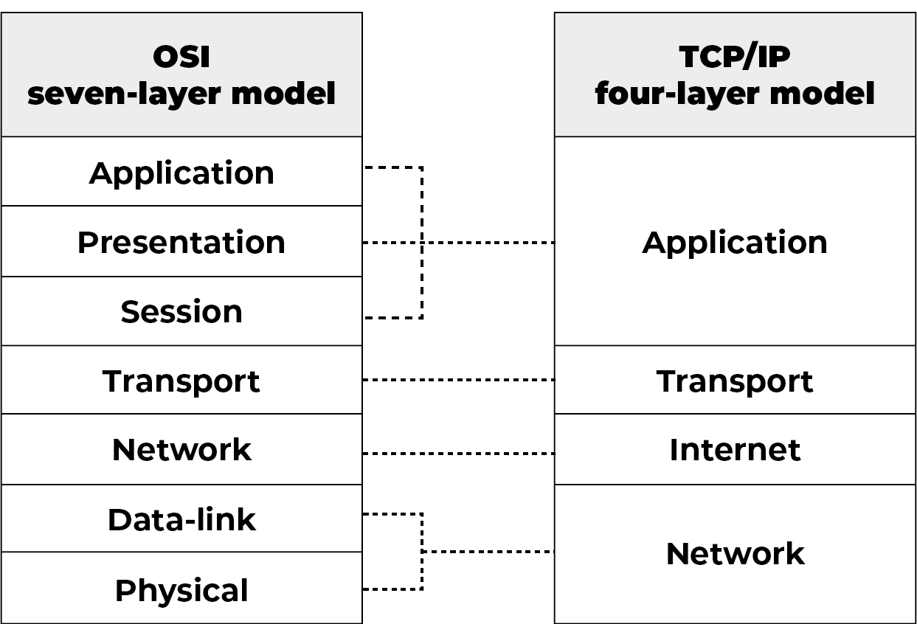

TCP/IP and OSI are the most widely used communication networking protocols. The main difference is that OSI is a conceptual model that is not practically used for communication. Rather, it defines how applications can communicate over a network. TCP/IP, on the other hand, is widely used to establish links and network interaction.

The TCP/IP protocols lay out standards on which the internet was created, while the OSI model provides guidelines on how communication has to be done. Therefore, TCP/IP is a more practical model.

The TCP/IP and OSI models have similarities and differences. The main similarity is in the way they are constructed as both use layers, although TCP/IP consists of just four layers, while the OSI model consists of the following seven layers:

Layer 7, the application layer, enables the user -- software or human -- to interact with the application or network when the user wants to read messages, transfer files or engage in other network-related activities.

Layer 6, the presentation layer, translates or formats data for the application layer based on the semantics or syntax that the app accepts.

Layer 5, the session layer, sets up, coordinates and terminates conversations between apps.

Layer 4, the transport layer, handles transferring data across a network and providing error-checking mechanisms and data flow controls.

Layer 3, the network layer, moves data into and through other networks.

Layer 2, the data link layer, handles problems that occur as a result of bit transmission errors.

Layer 1, the physical layer, transports data using electrical, mechanical or procedural interfaces.

The upper layer for both the TCP/IP model and the OSI model is the application layer. Although this layer performs the same tasks in each model, those tasks may vary depending on the data each receives.

The functions performed in each model are also similar because each uses a network layer and transport layer to operate. The TCP/IP and OSI models are each mostly used to transmit data packets. Although they will do so by different means and by different paths, they will still reach their destinations.

The similarities between the TCP/IP model and the OSI model include the following:

* They are both logical models.
* They define networking standards.
* They divide the network communication process in layers.
* They provide frameworks for creating and implementing networking standards and devices.
* They enable one manufacturer to make devices and network components that can coexist and work with the devices and components made by other manufacturers.

The differences between the TCP/IP model and the OSI model include the following:

* TCP/IP uses just one layer (application) to define the functionalities of the upper layers, while OSI uses three layers (application, presentation and session).
* TCP/IP uses one layer (physical) to define the functionalities of the bottom layers, while OSI uses two layers (physical and data link).
* The TCP/IP header size is 20 bytes, while the OSI header is 5 bytes.
* TCP/IP is a protocol-oriented standard, whereas OSI is a generic model based on the functionalities of each layer.
* TCP/IP follows a horizontal approach, while OSI follows a vertical approach.
* In TCP/IP, the protocols were developed first, and then the model was developed. In OSI, the model was developed first, and then the protocols in each layer were developed.
* TCP/IP helps establish a connection between different types of computers, whereas OSI helps standardize routers, switches, motherboards and other hardware.

**The history of TCP/IP**

The Defense Advanced Research Projects Agency, the research branch of the U.S. Department of Defense, created the TCP/IP model in the 1970s for use in ARPANET, a wide area network that preceded the internet. TCP/IP was originally designed for the Unix OS, and it has been built into all of the OSes that came after it.

The TCP/IP model and its related protocols are now maintained by the Internet Engineering Task Force.